UAE REFINARIES

1. Project Overview and Objective
This project involves cleaning, transforming, and analysing raw data using Excel and creating an interactive Power BI dashboard to derive meaningful business insights.
The main objective is to demonstrate data pre-processing techniques using Excel and an interactive Power BI dashboard visualization to make informed decisions.

2. Data Sources
- Source Description and Timeline: Refinery capacity distribution over UAE Emirates and 1975-2025.
- Domain: Oil & Gas

3. Problem Statement
- To analyze refinery performance across UAE Emirates and identify top-performing regions.
- To study how refinery age, capacity, and crude oil prices affect production and profit.
- To compare petrol, diesel, and gas output among refineries to find efficiency trends.
- To evaluate employee count and cost to understand their impact on refinery operations.
- To use the findings to help improve planning and decision-making in the oil & gas sector.

4. Attribute (Column /Features) Details:
Attribute Name | Data Type | Description
Refinery Name | String | Name of Refinery.
Emirate | String | The UAE Emirate where the refinery is located.
Operator | String | The organization managing the refinery.
Capacity_BPD | Numeric | Crude oil in Barrels which refinery processed daily.
Commissioned Year | Numeric | The year the refinery started operations.
N0_of Employees | Numeric | Total number of employees working in refinery.
Crude Source | Categorical | Origin of crude oil for all refineries.
Annual_Throughput_Million_Tons | Numeric | Annual output of crude oil from refinery.
Environmental Rating | Numeric | Refineries environmental rating and Standards.
Petrol_Output_BPD | Numeric | Quantity of Petrol extract from crude oil in barrel per day.
Diesel_Output_BPD | Numeric | Quantity of Diesel extract from crude oil in barrel per day.
Gas_Output_BPD | Numeric | Quantity of Gas extract from crude oil in barrel per day.
Employee Category | Categorical | Role of each employee working in refinery.
Average Salary | Numeric | Average Salary of employees per day.
Output Productivity/Day | Numeric | Productivity of total number of employees in refinery per day.
Employee Productivity Level | Categorical | Based on the employee productivity classified as “Low”, “Medium” & “High”.
Salary/Barrel | Numeric | Salary of employees per barrel on daily basis.
Petrol Efficiency | Percentage | Total quantity of petrol extract from the crude oil in percentage.
Diesel Efficiency | Percentage | Total quantity of Diesel extract from the crude oil in percentage.
Gas Efficiency | Percentage | Total quantity of Gas extract from the crude oil in percentage.
Clean Energy | Categorical | Based on the environmental refineries are classified as “Good”, “Excellent” & “Poor”.
Refinery Age | Numeric | The number of years since the refinery was commissioned.
Cost/Barrel | Numeric | Cost of crude oil per barrel in AED
Revenue/Day | Numeric | Total Revenue of refineries per day.
Cost of Crude Oil as of each year | Numeric | Average cost of crude from the year 1975-2025.
Employee ID | Numeric | Unique identification number assigned to each employee working in the refineries.

5. Tools & Technologies
- Excel: Data cleaning, transformation, and Pivot Tables.
- Power BI: Data modelling, DAX calculations, visualization, and interactive dashboard creation.

6. Data Pre-Processing (Excel / Power Query)

Tasks Performed:
- Data Cleaning & Transformation:
Created the calculated fields to find Productivity of employees per day, Employees salary per barrel, Efficiency of Petrol, Diesel and Gas, profit per barrel, Refinery Age &Revenue.
- Filtering & Sorting: Data was filtered to find refineries overall productivity in each emirate.
- Pivot Tables: Generated Pivot Tables for data summarization and initial insights.
  - Create Pivot Tables for top 10 refineries.
  - Create Pivot table to analyse productivity by crude sources.
- Fact Table are converted to three Dimensional Table

7. Data Modelling and DAX (Power BI)
- Data Model: Established relationships between tables, defined cardinality, and created lookup tables where necessary.
- Relationship created for main table and dimensional table

SCREENSHOT OF DATA MODELLING
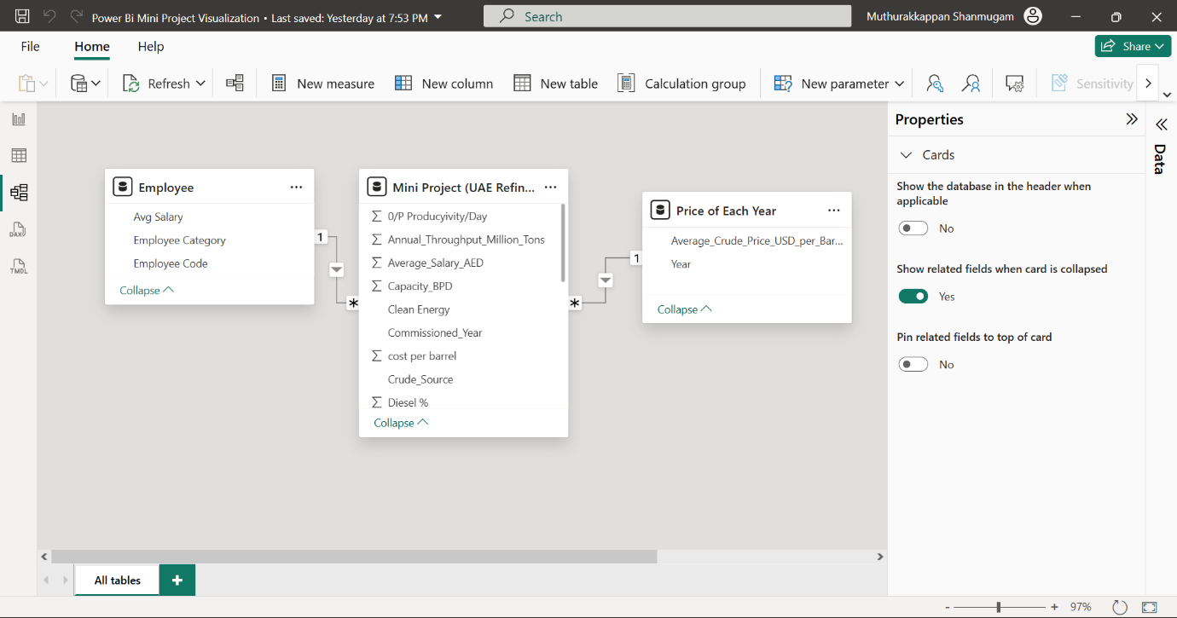

- Calculated Columns & DAX Measures: Implemented DAX formulas for key metrics, such as total sales, growth percentages, and cumulative totals.
1.Created new column for profit calculation.
2.Used Dax formula to identify total revenue per day, total crude oil per day, summarize quantity of crude oil in different refinery, calculate function to identify revenue in each emirates.

8. Analysis and Visualizations (Power BI)

Dashboard Features:
- Multiple Visualizations based on problem statement: Bar charts, line charts, pie charts, cards, and tables to communicate insights.
1. Bar chart for crude oil BPD VS Emirates & Operator.
2. Pie chart for gas, petrol & diesel efficiency.
3. Combo Chart for Refinery VS Age & its Efficiency.
4. Narrative cards to used to communicate insights ie High productivity refineries & its Operator.
5. Multiple Cards to specify details of high productivity refineries productivity of crude oil, extracted Oil, Gas and Petrol & profit.
- Drill-down are used to represent details of operator with its refineries and emirates. Filters and slicers
- Created a consolidated Report /Dashboard.

Descriptive Analysis

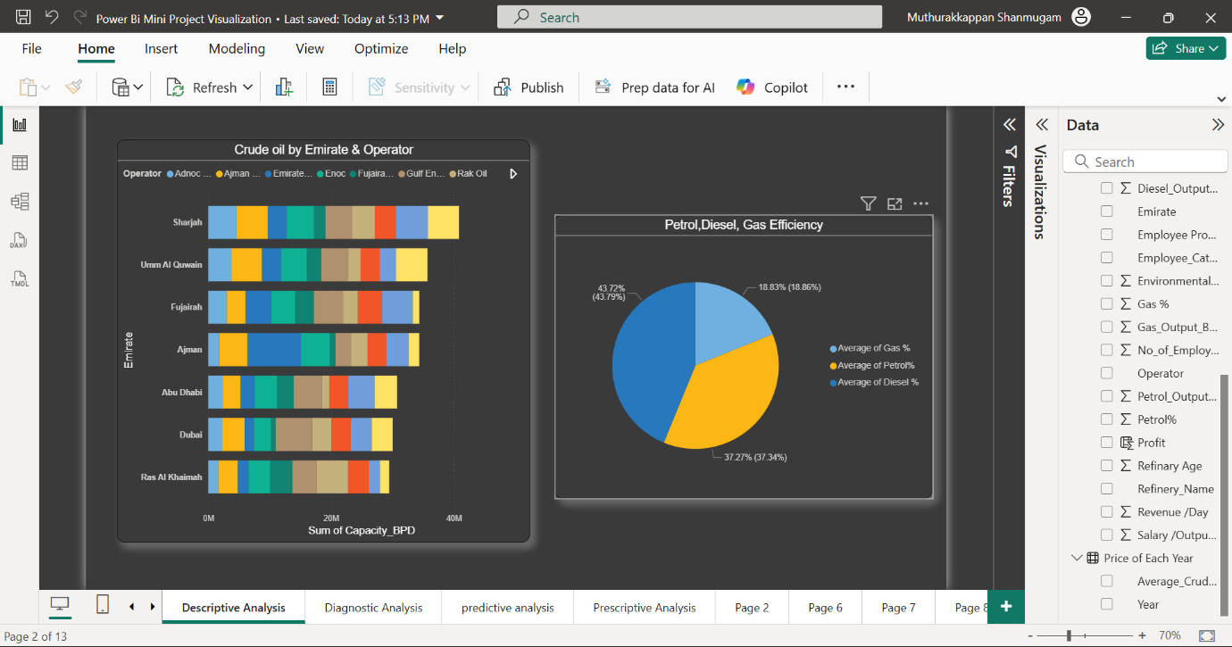

Diagnostic Analysis

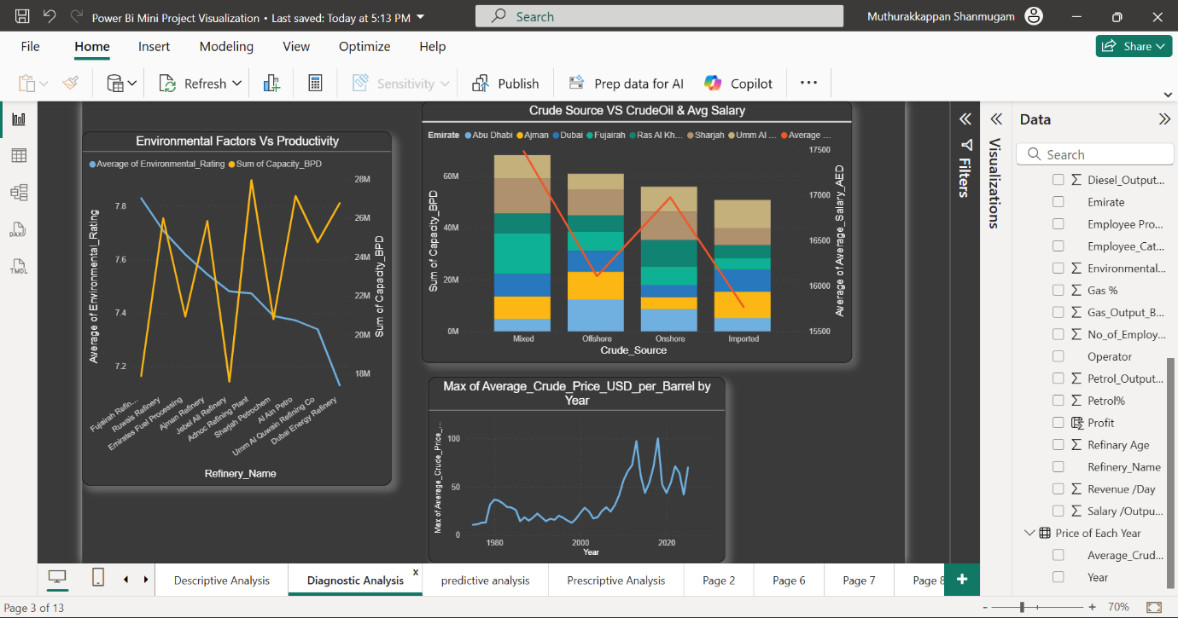

Predictive Analysis

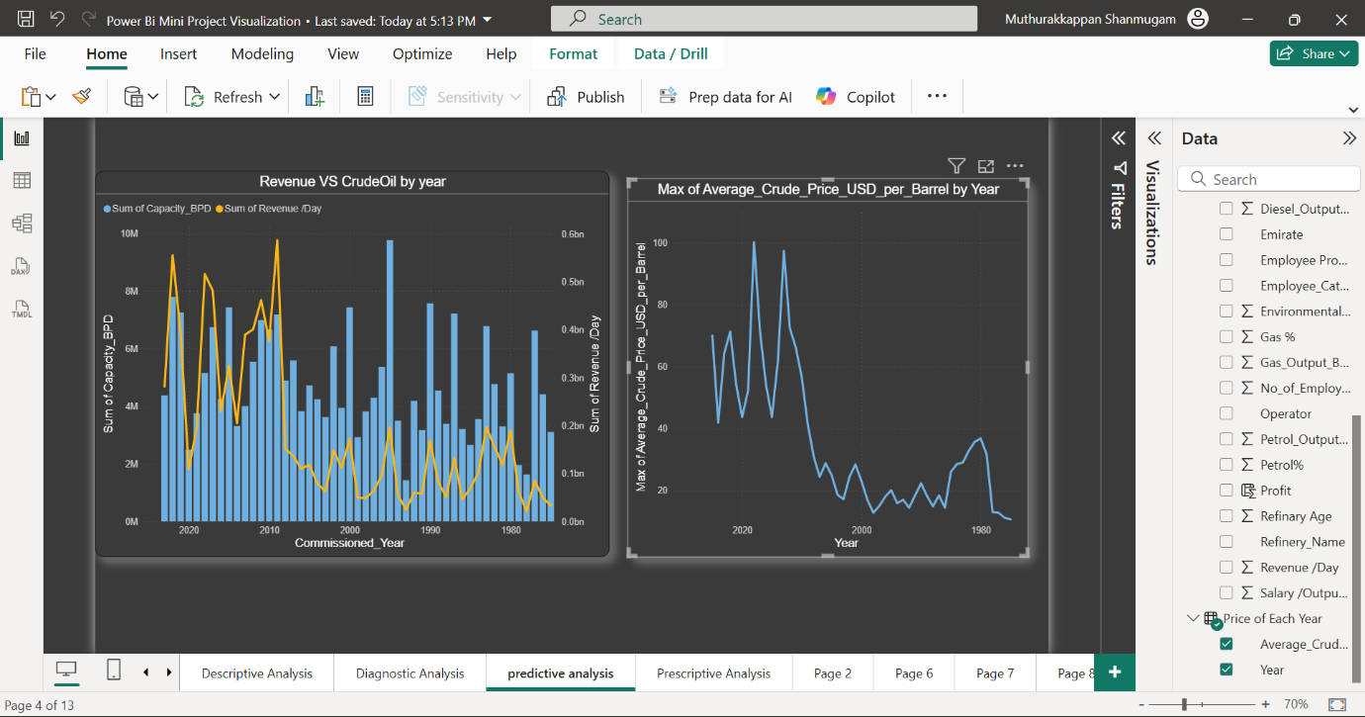

Prescriptive Analysis

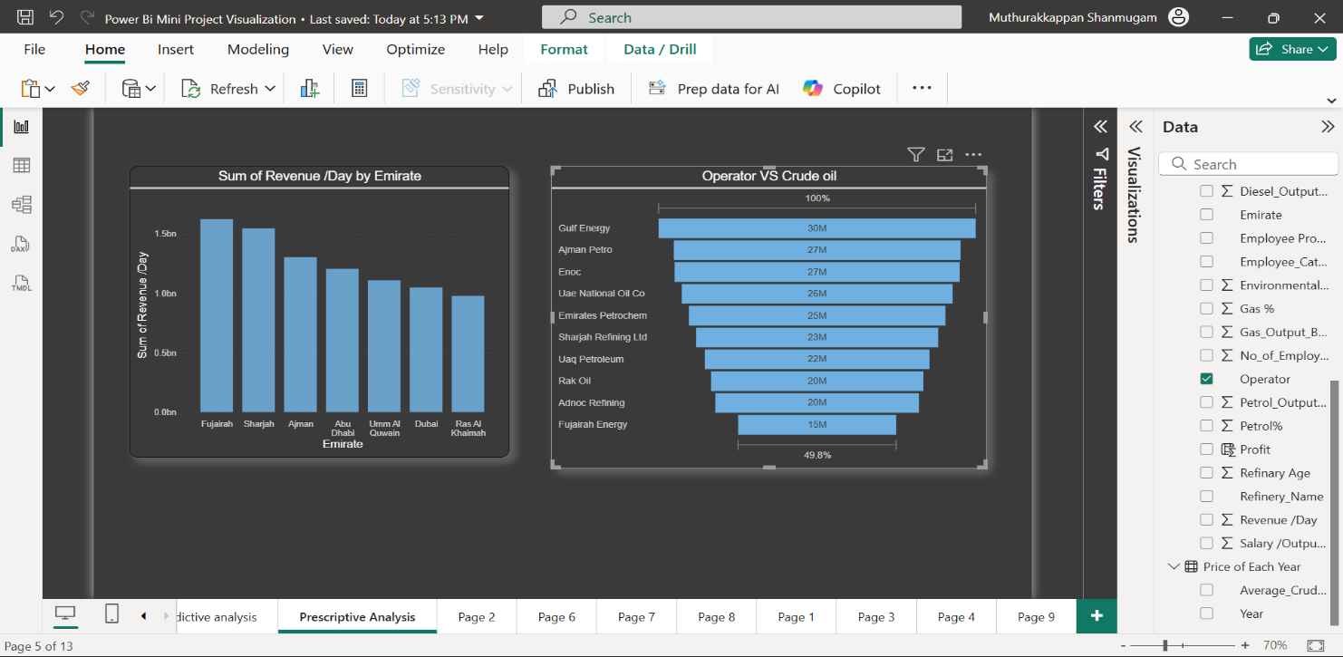

Consolidated Refinery Insights Report

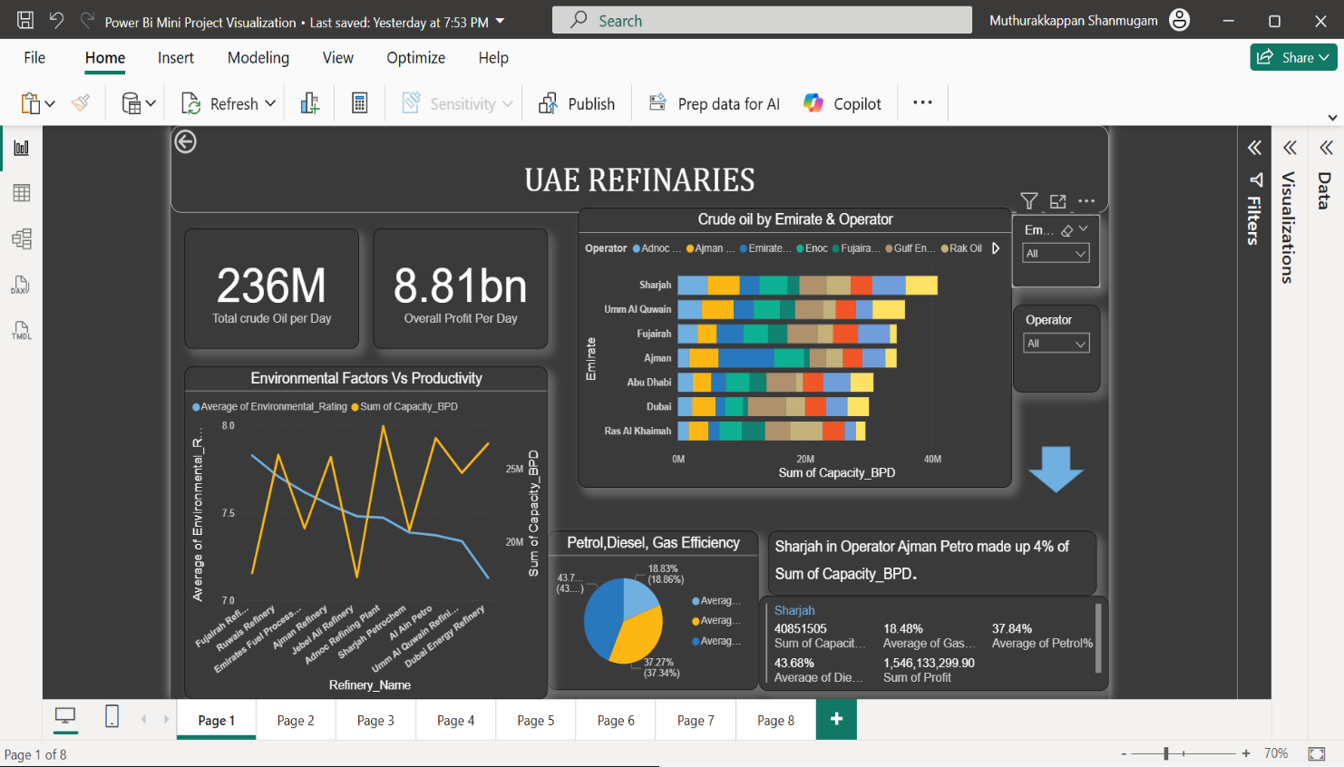

9. Insights & Conclusions

- Key Findings:
- Sharjah Refinery recorded the highest overall production capacity and revenue, contributing approximately 19% of the total refining output in the dataset.
- The overall trend shows steady growth in refining capacity and profit with minor dips corresponding to fluctuations in global crude oil prices.

- Analysis insight
EMIRATES | Total Capacity BPD
Sharjah | 40851505
Um Al Quwain | 35718228
Fujairah | 34402496
Ajman | 34393102
Abu Dhabi | 30763738
Dubai | 30040449
Ras Al Khaimah | 29495496

- Efficiency of Diesel is higher than the Petrol and Gas.
- Um Al Quwain Refineries has highest revenue because major refineries are Onshore
- Renovate low-output refineries.
- Invest in top 3 high-margin operators.
- Upgrade technology for low-rated plants and Expand capacity and support top-performing operators to boost daily profit.

10. Conclusions
The combined analysis in Excel and Power BI revealed that UAE refineries achieve a total crude capacity of 236M BPD and a daily profit of AED 8.81B. While high-performing plants drive most of the profit, lower-rated refineries show potential for improvement through technology upgrades and optimized crude distribution. Overall, the study highlights opportunities to enhance refinery efficiency, profitability, and environmental sustainability across the UAE.

